**Chapter 6**

**Vector Calculus**

**6.6 Surface Integrals**

**Section Exercises**

**For the following exercises, determine whether the statements are *true or false*.**

269. If surface *S* is given by , then 

Answer: True

271. Surface , is the same as surface , for 

Answer: True

**For the following exercises, find parametric descriptions for the following surfaces.**

273. Plane 

Answer:  for  and 

275. Plane 

Answer:  for  and 

277. The portion of cylinder  in the first octant, for 

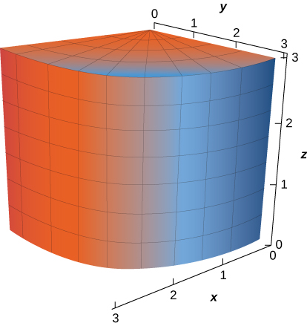

Answer:  for 

**For the following exercises, use a computer algebra system to approximate the area of the following surfaces using a parametric description of the surface.**

279. **[T]** Half cylinder 

Answer: 

**For the following exercises, let *S* be the hemisphere  with  and evaluate each surface integral, in the counterclockwise direction.**

281. 

Answer:

283. 

Answer: 

**For the following exercises, evaluate  for vector field F, where N is an outward normal vector to surface *S.***

285.  and *S* is hemisphere 

Answer: 

**For the following exercises, approximate the mass of the homogeneous lamina that has the shape of given surface *S.* Round to four decimal places.**

287. **[T]** *S* is surface 

Answer: 

289. **[T]** *S* is surface 

Answer: 

291. Evaluate surface integral , where  and *S* is the portion of plane  that lies over unit square *R*: 

Answer: 

293. **[T]** Evaluate  where *S* is the surface defined by 

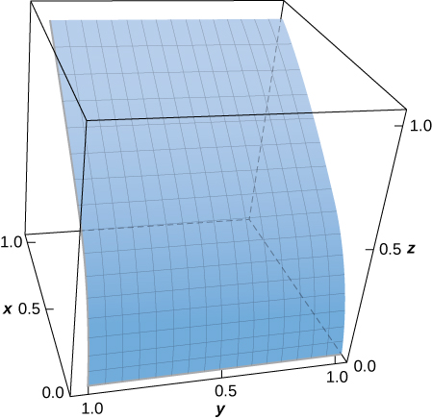

Answer: 

295. Evaluate  where *S* is the surface bounded above hemisphere  and below by plane 

Answer: 

297. **[T]** Evaluate where *S* is the portion of cone  that lies between planes  and 

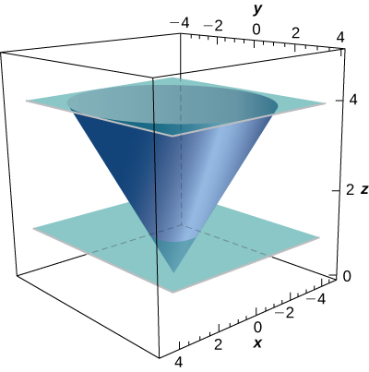

Answer: 

299. **[T]** Evaluate where *S* is the part of the graph of  in the first octant between the *xz*-plane and plane 

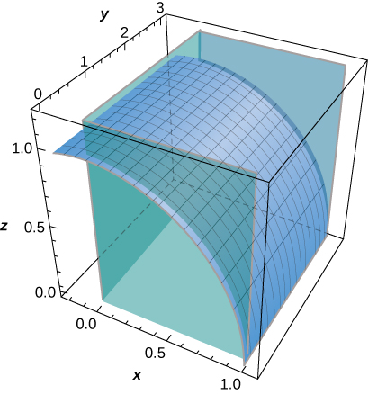

Answer: 

301. Find the mass of a lamina of density  in the shape of hemisphere 

Answer: 

303. Compute  where  and **N** is an outward normal vector *S*, where Sis the triangular region cut off from plane  by the positive coordinate axes.

Answer: 

305. Compute  where  and **N** is an outward normal vector *S*, where *S* is the surface of the five faces of the unit cube  missing 

Answer: 

**For the following exercises, express the surface integral as an iterated double integral by using a projection on *S* on the *yz*-plane.**

307.  *S* is the portion of the graph of  bounded by the coordinate planes and plane 

Answer: 

**For the following exercises, express the surface integral as an iterated double integral by using a projection on *S* on the *xz*-plane**

309.  *S* is the portion of the graph of  bounded by the coordinate planes and plane 

Answer: 

311. Evaluate surface integral  where *S* is hemisphere

Answer: 

313. Evaluate surface integral  where *S* is the part of plane  that lies above rectangle 

Answer: 

315. Evaluate surface integral  where *S* is the part of plane  that lies inside cylinder 

Answer: 

**For the following exercises, use geometric reasoning to evaluate the given surface integrals.**

317.  where *S* is surface  oriented with unit normal vectors pointing outward

Answer: 

319. A lamina has the shape of a portion of sphere  that lies within cone  Let *S* be the spherical shell centered at the origin with radius *a*, and let *C* be the right circular cone with a vertex at the origin and an axis of symmetry that coincides with the *z*-axis. Determine the mass of the lamina if 

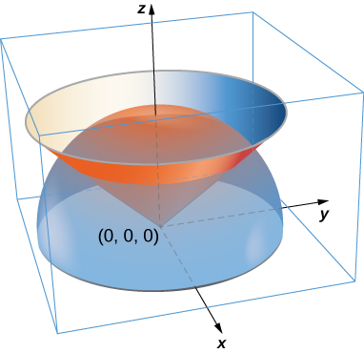

Answer: 

321. A paper cup has the shape of an inverted right circular cone of height 6 in. and radius of top 3 in. If the cup is full of water weighing  find the total force exerted by the water on the inside surface of the cup.

Answer: 

**For the following exercises, the heat flow vector field for conducting objects i is the temperature in the object and  is a constant that depends on the material. Find the outward flux of F across the following surfaces *S* for the given temperature distributions and assume **

323. *S* is sphere 

Answer: 

**For the following exercises, consider the radial fields  where *p* is a real number. Let *S* consist of spheres *A* and *B* centered at the origin with radii  The total outward flux across *S* consists of the outward flux across the outer sphere *B* less the flux into *S* across inner sphere *A*.**

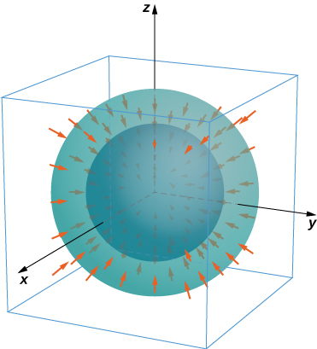

325. Show that for  the flux across *S* is independent of *a* and *b*.

Answer: The net flux is zero.

This file is copyright 2016, Rice University. All Rights Reserved.